Installation Document

1. Installation requirements
   1. EclipseIDE (<https://eclipse.org/downloads>)
   2. Tomcat Webserver (<https://tomcat.apache.org/download-80.cgi>)
   3. GitHub
2. Installation Steps
3. Clone Git Repository (<https://github.com/christalvz/pacteraExam.git>)
4. Import source as existing maven project
5. Build and install source code
6. Run on Tomcat server
7. Screenshots of running codes

http://Localhost:8080/PacteraExamWeather/

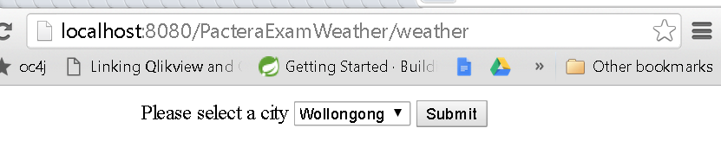

2. select city and click submit

